Karta 1

[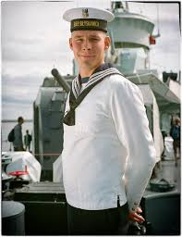](https://www.google.de/url?sa=i&url=https%3A%2F%2Fpl-pl.facebook.com%2FPolskaZbrojna%2Fphotos%2Fmarynarz-maciej-w%25C4%2599sierski-orp-b%25C5%2582yskawica-od-dziecka-chcia%25C5%2582em-nosi%25C4%2587-mundur-maryna%2F1274384989246447%2F&psig=AOvVaw3xq17hgzeM0h7qcqbjna2l&ust=1592993385056000&source=images&cd=vfe&ved=0CAIQjRxqFwoTCLiHiI_Zl-oCFQAAAAAdAAAAABAI) [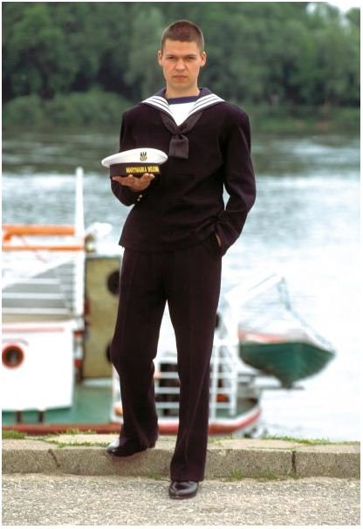](https://www.google.de/url?sa=i&url=https%3A%2F%2Fpl.all.biz%2Fmundur-marynarza-zimowy-g124169&psig=AOvVaw0pOlDTzmWVpP_iutODwV1C&ust=1592993572837000&source=images&cd=vfe&ved=0CAIQjRxqFwoTCNDi0-jZl-oCFQAAAAAdAAAAABAD)

[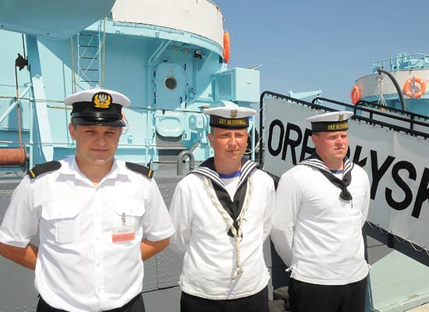](https://www.google.de/url?sa=i&url=https%3A%2F%2Fwiadomosci.wp.pl%2Fmarynarze-uratowali-tonaca-kobiete-6037429026607745a&psig=AOvVaw2X7rd7liaIoP0C4ZTCHxn5&ust=1592993736193000&source=images&cd=vfe&ved=0CAIQjRxqFwoTCLiP56Pal-oCFQAAAAAdAAAAABAJ)